How to: creating what-if scenarios
What-if scenarios can be useful in many cases. The sales driven organization for example, can take advantage of understanding the impact of rising costs, decreasing quantities of sold goods, changes in selling prices and how all of this affects the margin, just in a few simple clicks. It’s quite simple to create such a what-if scenario in Qlikview. This how to gives you a step by step explanation.
The first thing to do is declaring variables for sliders to increase or decrease the values in percentage (%) for Sales, Cost or Quantity. Navigate to settings and choose Variable Overview.
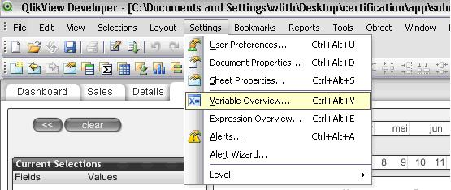
In the variable overview, add the three new variables: vQty2, vCost2 and vSales2.
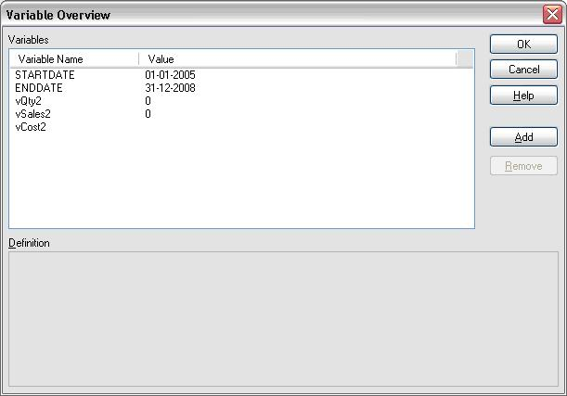
Now create three independent sliders with the following settings:
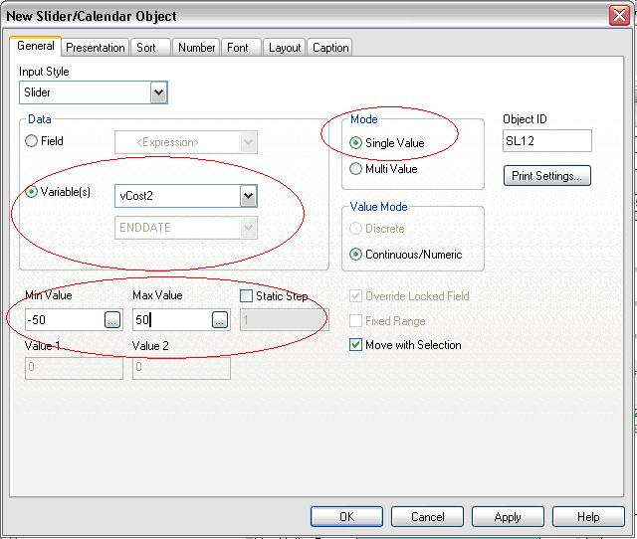
The cost, sales and Qty percentage (see picture below) text can be created by adding a text object with:
=’Cost: ‘&chr(10)&num($(vCost2)/100,’##.0%;-##.0%’)
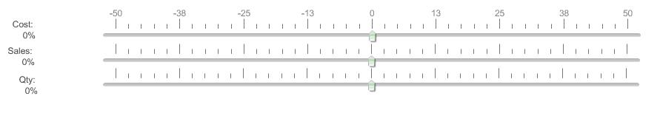
Next thing to do is creating a straight table containing products as dimension and the following expressions:
• Actual Avg Sales
Sum([Sales])/Sum([Quantity])
• What if Sales
[Actual Avg Sales] * (1 + vSales2/100)
• Actual Avg Cost\
Sum(Cost)/Sum(Quantity)
• What-if Cost
[Actual Avg Cost] * (1 + vCost2/100)
• Actual Qty Sold
Sum(Quantity)
• What-if Qty
[Actual Qty Sold] * (1+vQty2/100)
• Actual Margin
Sum(Margin)
• What-if Margin Inc / Decr
[What-if Margin Total €] – [Actual Margin €]
• What-if Margin Total
([Actual Qty Sold] * (1+vQty2/100))*(([Actual Avg Sales] * (1 + vSales2/100)) – ([Actual Avg Cost] * (1 + vCost2/100)))
When you finished the straight table, all you have to do is change the sliders to see the direct impact of changing costs, sales or quantities.
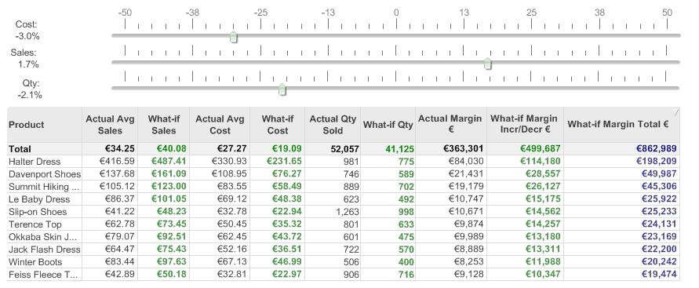
Of course there is the possibility to visualize what happens by creating some bar charts. Just copy the straight table and adjust the settings to your own wishes. Enjoy!
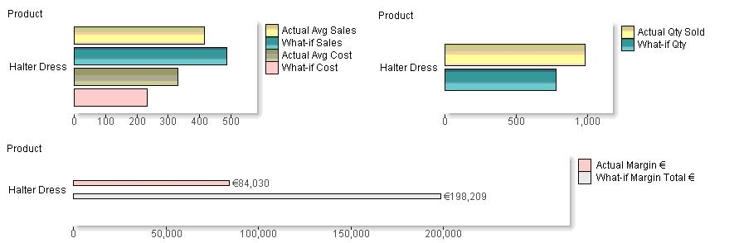
Share and Enjoy:

